Design and analysis of Water Jet nozzle
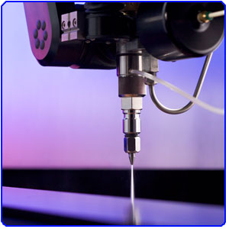

Abstract:
Water jet technology evolved in the post-war era as researchers around the world searched for new methods of efficient cutting systems. In 1956, Carl Johnson of Durox International in Luxembourg developed a method for cutting plastic shapes using a thin stream high-pressure water jet, but those materials, like paper, were soft materials.
Water jet cutting is an industrial cutting tool used to cut wide variety of materials using a high pressure of water or a mixture of water and abrasive material to cut hard materials like granite or metals. pure water jet and water-only cutting refer to water jet cutting without the use of added abrasives, often used for softer materials such as wood or rubber.
It is the preferred method when the materials being cut are sensitive to the high temperatures generated by other methods. Water jet cutting is used in various industries, including mining and aerospace, for cutting, shaping, and reaming.
In this project we generate the model of water jet nozzle and analysis is performed in solid works premium 2014.

